MulliganOddsCalculator Documentation

Overview
The MulliganOddsCalculator is a Java class designed to simulate and calculate the probability of getting a mulligan in a Pokémon Trading Card Game. A mulligan occurs when a player's opening hand contains no Pokémon cards, requiring them to reshuffle and draw a new hand.

Properties

totalExperiments ( int) = Number of simulations to run for each calculation
handSize (int)=Number of cards drawn in an opening hand
deckSize (int )=Total number of cards in the deck

Methods

calculateOdds()
Calculates and displays mulligan probabilities for different numbers of Pokémon cards.
- Iterates through possible Pokémon card counts (1 to deckSize)
- Runs specified number of experiments
- Displays results in format: "With X Pokémon cards: Y.YY% chance of a mulligan"

Private Methods
isMulligan(int pokemonCount, int deckSize, int handSize)
Simulates drawing a hand and checks for mulligan condition.
- Parameters:
- pokemonCount: Number of Pokémon cards in deck
- deckSize: Total number of cards in deck
- handSize: Number of cards to draw
- Returns: boolean (true if mulligan)

## Usage Example

MulliganOddsCalculator calculator = new MulliganOddsCalculator(10000, 7, 60);
calculator.calculateOdds();
With 1 Pokémon cards: 88.72% chance of a mulligan
With 2 Pokémon cards: 79.35% chance of a mulligan
With 3 Pokémon cards: 69.94% chance of a mulligan
With 4 Pokémon cards: 61.36% chance of a mulligan
With 5 Pokémon cards: 54.15% chance of a mulligan
With 6 Pokémon cards: 47.57% chance of a mulligan
With 7 Pokémon cards: 41.79% chance of a mulligan
With 8 Pokémon cards: 37.45% chance of a mulligan
With 9 Pokémon cards: 31.84% chance of a mulligan
With 10 Pokémon cards: 28.23% chance of a mulligan
With 11 Pokémon cards: 24.21% chance of a mulligan
With 12 Pokémon cards: 20.98% chance of a mulligan
With 13 Pokémon cards: 18.49% chance of a mulligan
With 14 Pokémon cards: 15.53% chance of a mulligan
With 15 Pokémon cards: 14.04% chance of a mulligan
With 16 Pokémon cards: 11.27% chance of a mulligan
With 17 Pokémon cards: 10.04% chance of a mulligan
With 18 Pokémon cards: 8.10% chance of a mulligan
With 19 Pokémon cards: 6.75% chance of a mulligan
With 20 Pokémon cards: 5.67% chance of a mulligan
With 21 Pokémon cards: 4.53% chance of a mulligan
With 22 Pokémon cards: 3.99% chance of a mulligan
With 23 Pokémon cards: 3.18% chance of a mulligan
With 24 Pokémon cards: 2.96% chance of a mulligan
With 25 Pokémon cards: 2.12% chance of a mulligan
With 26 Pokémon cards: 2.22% chance of a mulligan
With 27 Pokémon cards: 1.51% chance of a mulligan
With 28 Pokémon cards: 1.28% chance of a mulligan
With 29 Pokémon cards: 1.11% chance of a mulligan
With 30 Pokémon cards: 0.80% chance of a mulligan
With 31 Pokémon cards: 0.55% chance of a mulligan
With 32 Pokémon cards: 0.44% chance of a mulligan
With 33 Pokémon cards: 0.33% chance of a mulligan
With 34 Pokémon cards: 0.21% chance of a mulligan
With 35 Pokémon cards: 0.18% chance of a mulligan
With 36 Pokémon cards: 0.11% chance of a mulligan
With 37 Pokémon cards: 0.13% chance of a mulligan
With 38 Pokémon cards: 0.12% chance of a mulligan
With 39 Pokémon cards: 0.07% chance of a mulligan
With 40 Pokémon cards: 0.06% chance of a mulligan
With 41 Pokémon cards: 0.04% chance of a mulligan
With 42 Pokémon cards: 0.04% chance of a mulligan
With 43 Pokémon cards: 0.01% chance of a mulligan
With 44 Pokémon cards: 0.02% chance of a mulligan
With 45 Pokémon cards: 0.02% chance of a mulligan
With 46 Pokémon cards: 0.00% chance of a mulligan
With 47 Pokémon cards: 0.00% chance of a mulligan
With 48 Pokémon cards: 0.00% chance of a mulligan
With 49 Pokémon cards: 0.00% chance of a mulligan
With 50 Pokémon cards: 0.00% chance of a mulligan
With 51 Pokémon cards: 0.00% chance of a mulligan
With 52 Pokémon cards: 0.00% chance of a mulligan
With 53 Pokémon cards: 0.00% chance of a mulligan
With 54 Pokémon cards: 0.00% chance of a mulligan
With 55 Pokémon cards: 0.00% chance of a mulligan
With 56 Pokémon cards: 0.00% chance of a mulligan
With 57 Pokémon cards: 0.00% chance of a mulligan
With 58 Pokémon cards: 0.00% chance of a mulligan
With 59 Pokémon cards: 0.00% chance of a mulligan
With 60 Pokémon cards: 0.00% chance of a mulligan

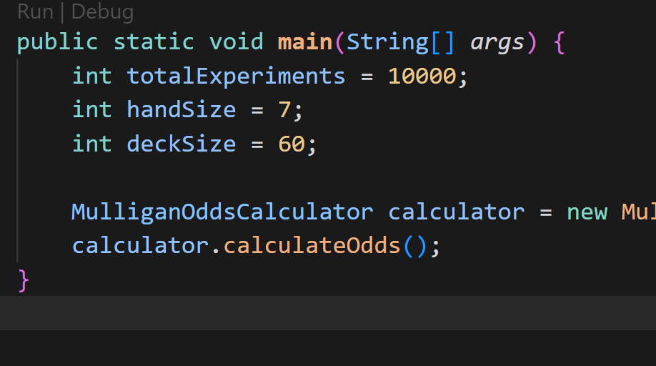

Rare Candy Probability Analysis
- Simulates probability of unplayable hands ("bricking") with different
- quantities of Rare Candy cards in a Pokemon TCG deck.
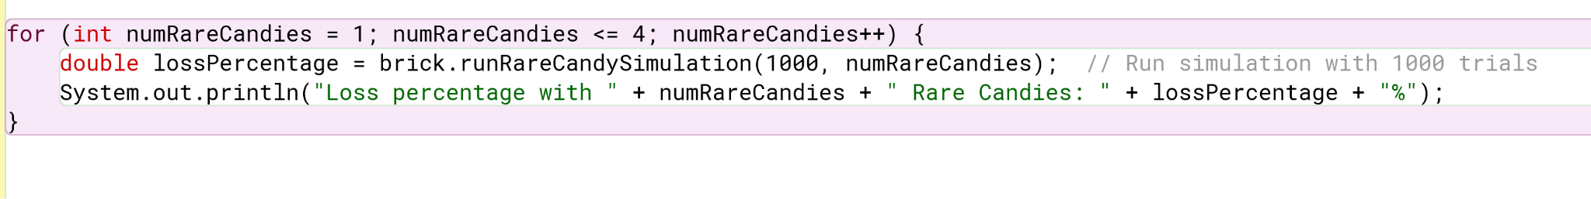
Results (1000 trials each):
- 1 Rare Candy: 11.1% loss rate
- 2 Rare Candies: 16.4% loss rate
- 3 Rare Candies: 24.9% loss rate
- 4 Rare Candies: 31.3% loss rate

